Terraform -04
1). Watch Terraform-04 video.
2). Executed the script shown in the video below:
Hands-on: Specify Terraform Provider Version
Step 1: Create a new folder
Run: mkdir provider-version-demo
Step 2: Go inside the folder
cd provider-version-demo
Your prompt should now be:
PS C:\Users\sriva\Desktop\Terraform-provider\provider-version-demo>
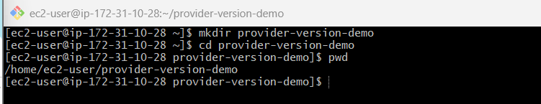
Step 3: Open this folder in VS Code
code .
Step 4: Create versions.tf
In VS Code, create:
versions.tf
Add:
terraform {
required_providers {
local = {
source = "hashicorp/local"
version = "2.5.2"
}
}
}
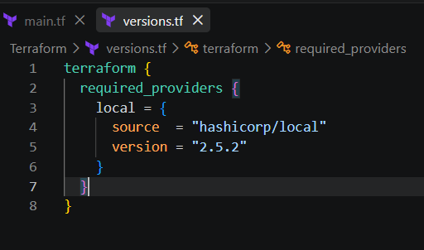
Step 5: Create main.tf
Create:
main.tf
Add:
provider "local" {}
resource "local_file" "example" {
filename = "example.txt"
content = "Hello from Terraform"
}
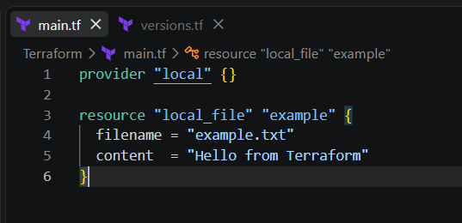
Step 6: Initialize Terraform
In the terminal:
terraform init
Terraform will download the local provider version 2.5.2.
Step 7: Verify the provider
terraform providers
You should see:
hashicorp/local
2.5.2
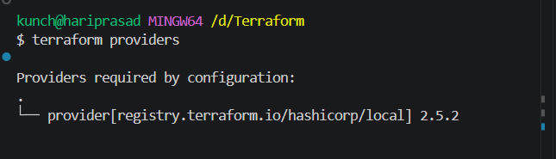
Step 8: Apply
terraform apply
Enter:
Yes
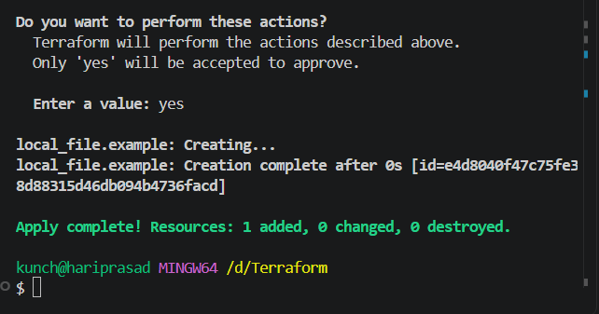
Step 9: modified version
Get-Content example.txt
You should get:
Terraform Provider Version Constraints – Hands-on
1. Go to your folder
cd C:\Users\sriva\Desktop\Terraform-provider\provider-version-demo
2. Test = Exact version
In versions.tf:
version = "= 2.5.0"
Run:
terraform init -upgrade
terraform providers
3. Test != Not equal
Change to:
version = "!= 2.5.0"
Run:
terraform init -upgrade
terraform providers
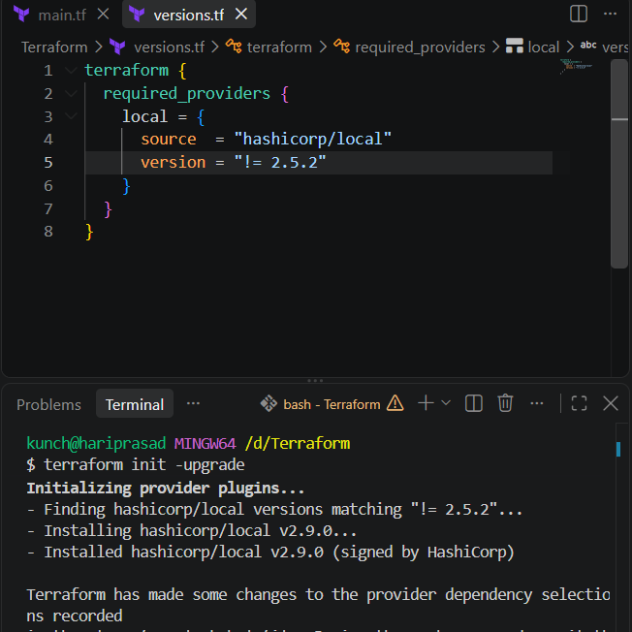
4. Test > Greater than
version = "> 2.5.0"
Run:
terraform init -upgrade
terraform providers
5. Test >= Greater than or equal
version = ">= 2.5.0"
Run:
terraform init -upgrade
terraform providers

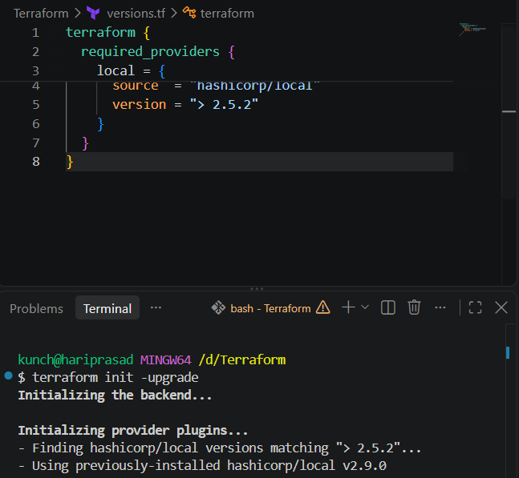
7. Test <= Less than or equal
version = "<= 2.5.0"
Run:
terraform init -upgrade
terraform providers
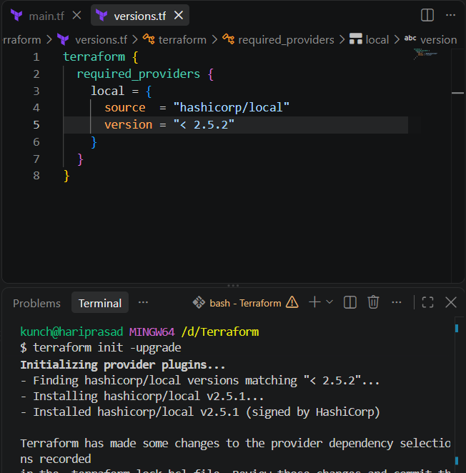
8. Test ~> Pessimistic constraint
version = "~> 2.5"
Run:
terraform init -upgrade
terraform providers
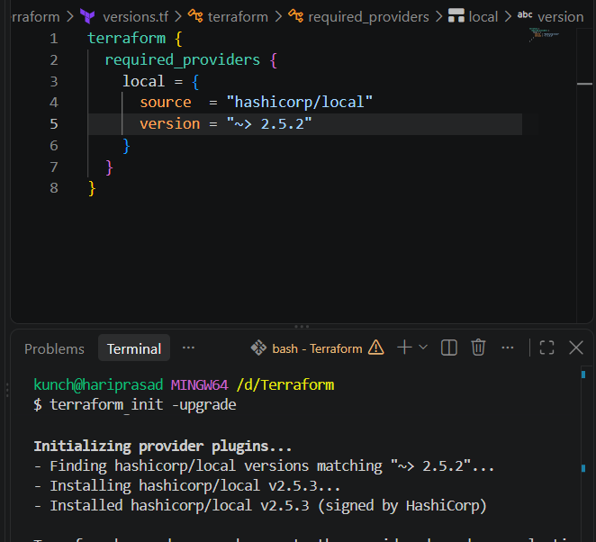
Terraform Data Source — Hands-on
We’ll use the local provider and read an existing file using a data source.
1. Create data.tf
data "local_file" "example" {
filename = "example.txt"
}
2. Keep main.tf
provider "local" {}
resource "local_file" "example" {
filename = "example.txt"
content = "Hello from Terraform"
}
3. Initialize
terraform init
4. Apply
terraform apply
This creates:
example.txt
5. Read the file using Data Source
Terraform init
terraform apply
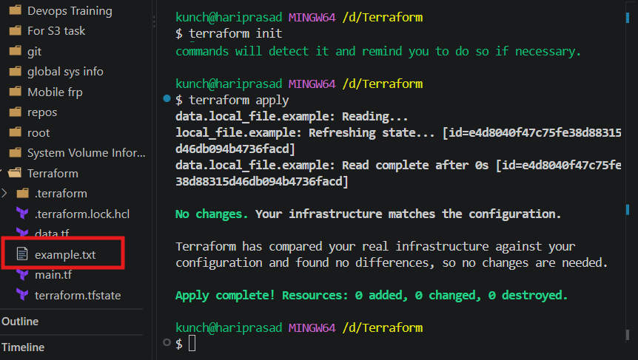
Terraform Meta-Arguments → count and for_each
Step 1 — Go to your Terraform folder
In PowerShell:
cd C:\Users\sriva\Desktop\Terraform-provider
Step 2 — Create a new folder
mkdir meta-arguments-demo
Go inside:
cd meta-arguments-demo
Your location should now be:
C:\Users\sriva\Desktop\Terraform-provider\meta-arguments-demo
Part 1: Hands-on count
Step 3 — Create main.tf
In VS Code, open:
meta-arguments-demo
Create:
main.tf
Create variable.tf
Step 4 — Initialize Terraform
In PowerShell:
terraform init
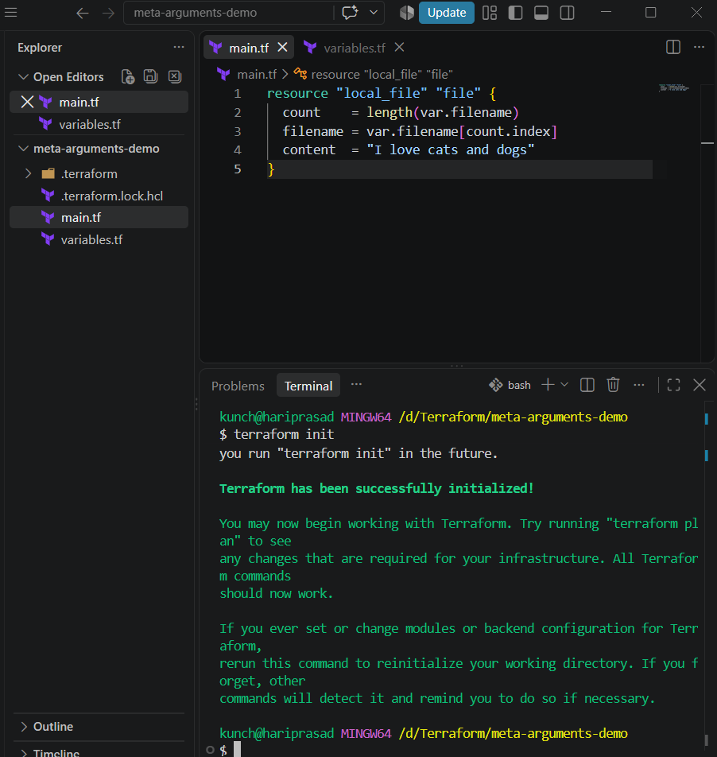
Step 5 — Check the plan
terraform plan
You should see:
Plan: 3 to add, 0 to change, 0 to destroy
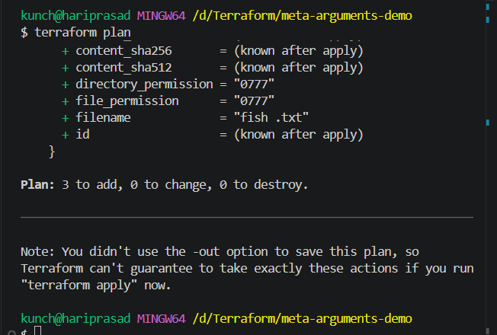
Step 6 — Apply
terraform apply
Type:
yes
Step 7 — Check files
Get-ChildItem
You should have:
file-0.txt
file-1.txt
file-2.txt
main.tf
count completed.
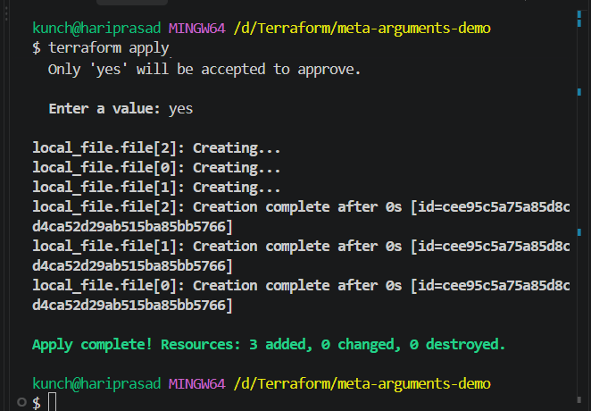
Dynamic Resource Creation Using length() ---best practice
1. variables.tf
variable "filename" {
default = ["dog.txt", "cat.txt", "fish .txt"]
}
2. main.tf
resource "local_file" "file" {
count = length(var.filename)
filename = var.filename[count.index]
content = "I love cats and dogs"
}
3. Run
terraform init
terraform plan
terraform apply
Meta Arguments
for_each
1. Create folder:
cd C:\Users\sriva\Desktop\Terraform-provider
mkdir for-each-demo
cd for-each-demo
2. for_each.tf
3. main.tf
4. Run:
terraform init
terraform plan
terraform apply
Type yes.
5. Result:
Option 1
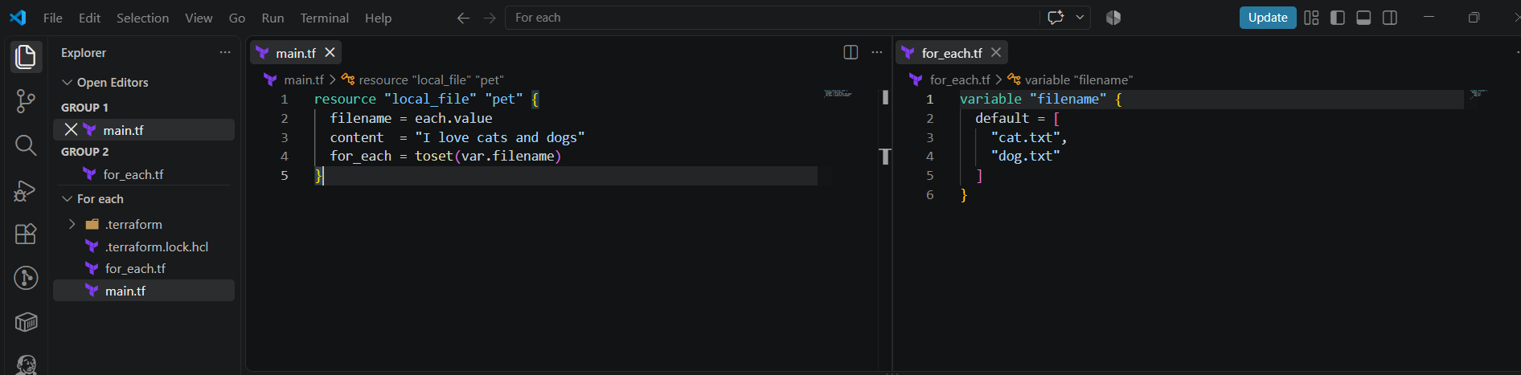
Option2
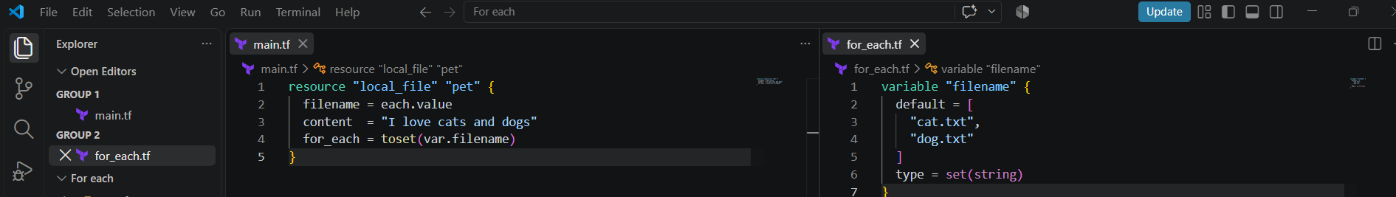
TASK 3 — Integrate Terraform in Jenkins using Terraform Plugin
🎯 Objective
We want this flow:
Developer
|
v
GitHub
|
v
Jenkins
|
+---- Terraform Init
|
+---- Terraform Plan
|
+---- Terraform Apply
|
v
AWS Infrastructure

STEP 1 — Verify Terraform on Jenkins Server
Login to your Jenkins EC2/server.
terraform version
Expected:
Terraform v1.x.x
Also check:
which terraform
Example:
/usr/local/bin/terraform
If Terraform is not installed, install it first.
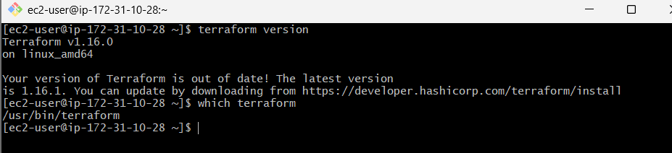

STEP 2 — Install Terraform Plugin
Go to:
Jenkins
↓
Manage Jenkins
↓
Plugins
↓
Available plugins
Search:
Terraform
Install:
Terraform
The Jenkins Terraform plugin provides Terraform integration and can configure a Terraform binary through Jenkins.
Restart Jenkins if required.
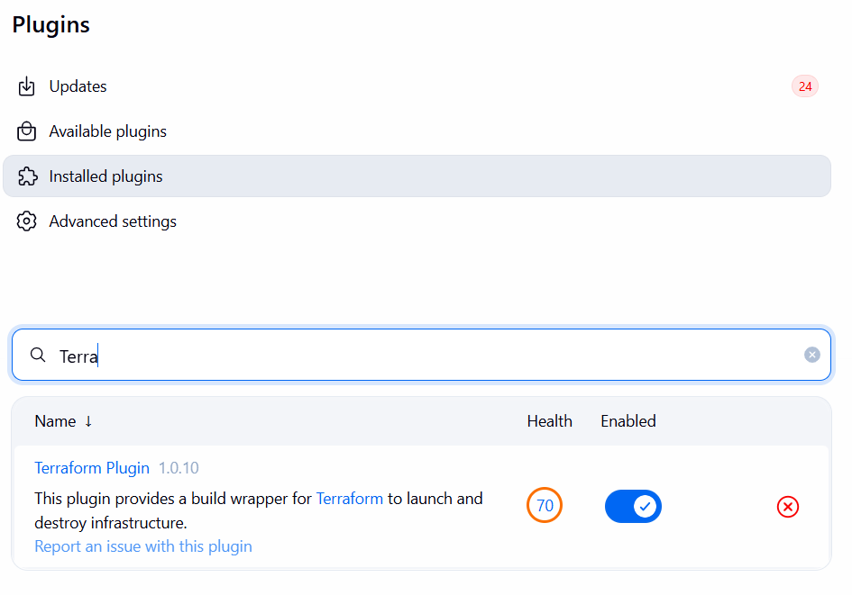

STEP 3 — Configure Terraform in Jenkins
Go to:
Manage Jenkins
↓
Tools
Find:
Terraform installations
Click:
Add Terraform
Example:
Name:
terraform

Install automatically:
☑
Or if Terraform is already installed on the server:
Name:
terraform

Terraform installation directory:
/usr/local/bin
The exact fields can vary depending on your Jenkins/plugin version.
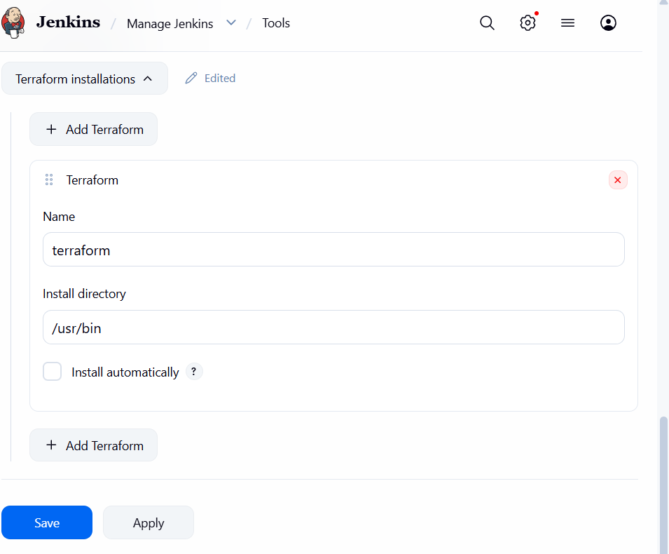

STEP 4 — Create Terraform Project
For practice, create a GitHub repository:
terraform-jenkins-demo
Structure:
terraform-jenkins-demo/
│
├── main.tf
├── variables.tf
├── terraform.tfvars
└── outputs.tf
Example main.tf:
provider "aws" {
region = "us-east-1"
}

resource "aws_s3_bucket" "demo" {
bucket = "terraform-jenkins-demo-123456789"
}
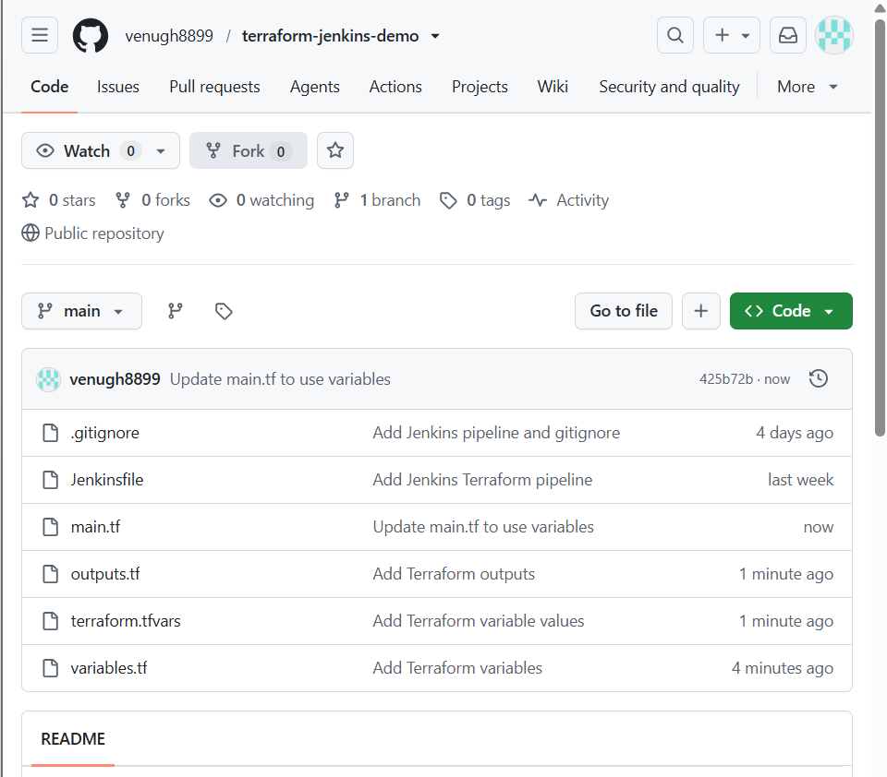

STEP 5 — AWS Credentials
Jenkins needs permission to create AWS resources.
Do not hard-code this:
AWS_ACCESS_KEY_ID=xxxxx
AWS_SECRET_ACCESS_KEY=xxxxx
inside your Jenkinsfile.
Instead, preferably use:
Jenkins Credentials
or an IAM role when your Jenkins EC2 architecture supports it.
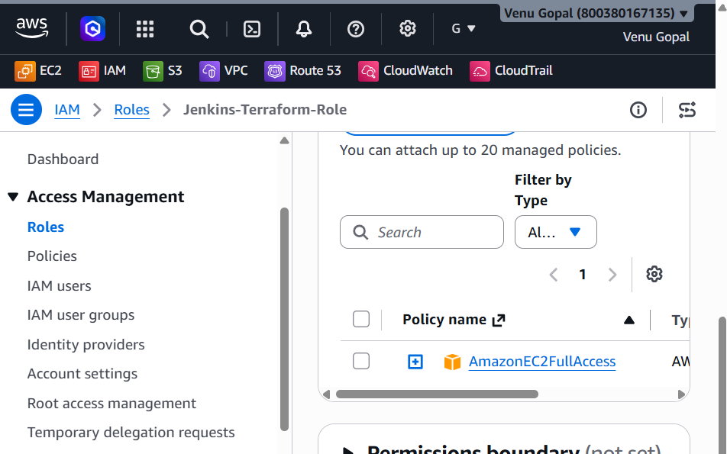

STEP 6 — Create Jenkins Pipeline
Create:
New Item
Name:
Terraform-Pipeline
Select:
Pipeline
Click:
OK

STEP 7 — Jenkins Pipeline
- Open Terraform-Pipeline in Jenkins.
- Click Configure.
- Under Pipeline:
  - Definition: Pipeline script from SCM
  - SCM: Git
  - Repository:
https://github.com/venugh8899/terraform-jenkins-demo.git
  - Branch:
*/main
  - Script Path:
Jenkinsfile
- Click Save.
- Click Build Now.
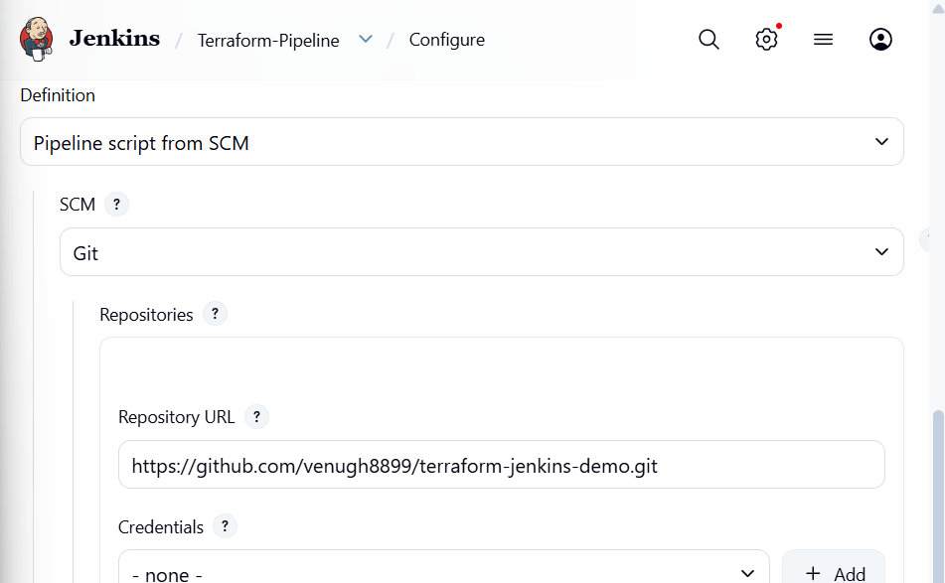

STEP 8 — Run Pipeline
Click:
Build Now
You should see:
Checkout
↓
Terraform Version
↓
Terraform Init
↓
Terraform Validate
↓
Terraform Plan
↓
Terraform Apply
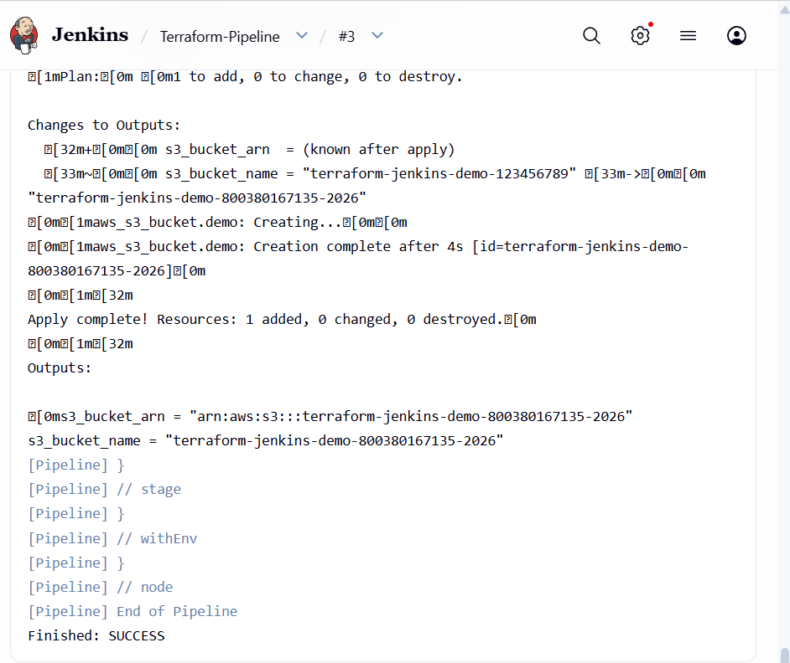

STEP 9 — Verify AWS
Go to AWS.
For our example:
AWS
↓
S3
↓
Buckets
You should see:
terraform-jenkins-demo-123456789
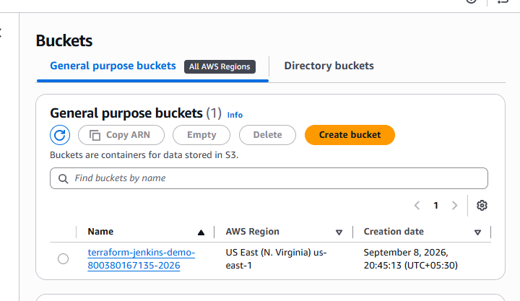

STEP 10 — Understand the Jenkins + Terraform Flow
Remember this for interviews:
GitHub
↓
Jenkins Checkout
↓
terraform init
↓
terraform validate
↓
terraform plan
↓
terraform apply
↓
AWS
Why Jenkins?
Terraform by itself provisions infrastructure.
Jenkins automates when and how Terraform runs.
So:
Terraform = Infrastructure as Code
Jenkins = Automation / CI-CD

TASK 4 — CI/CD Pipeline for Node.js Trading Application
Repository:
Trading-UI GitHub Repository
Our objective:
Developer
|
v
GitHub
|
v
Jenkins
|
+----------------+
| |
v v
Install Test
| |
+-------+--------+
|
v
Build
|
v
Deploy
|
v
Trading UI

STEP 1 — Clone the Application
On your Jenkins server:
git clone https://github.com/betawins/Trading-UI.git
Enter the directory:
cd Trading-UI
Check files:
ls -la
We specifically need to check:
package.json
because this tells us the Node.js project's available scripts.
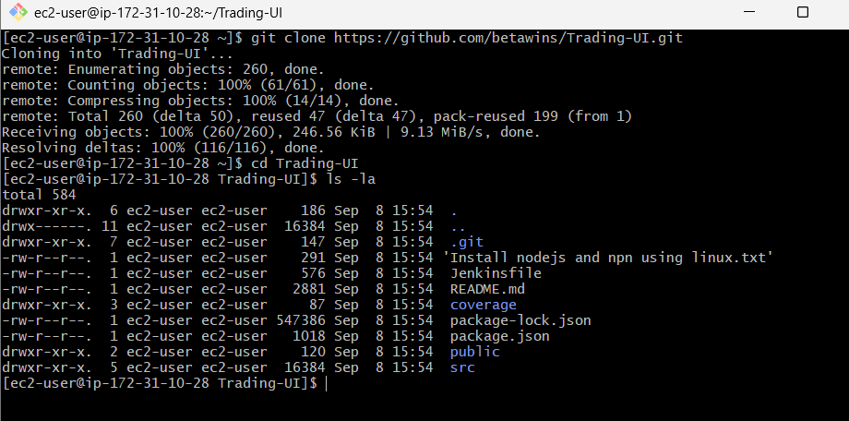

STEP 2 — Install Node.js
Check:
node --version
and:
npm --version
If missing, install Node.js.
For a Jenkins environment, make sure the Node version matches what the application's package.json requires.
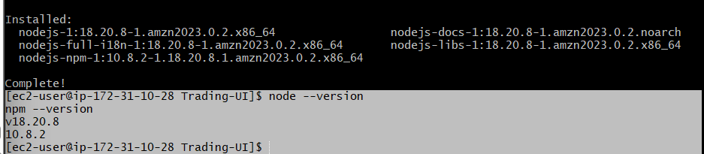

STEP 3 — Understand package.json
Run:
cat package.json
Look for:
"scripts": {
"start": "...",
"test": "...",
"build": "..."
}
For example:
npm install
npm test
npm run build
The actual build command should come from the repository's package.json, rather than assuming every Node.js project uses the same command.
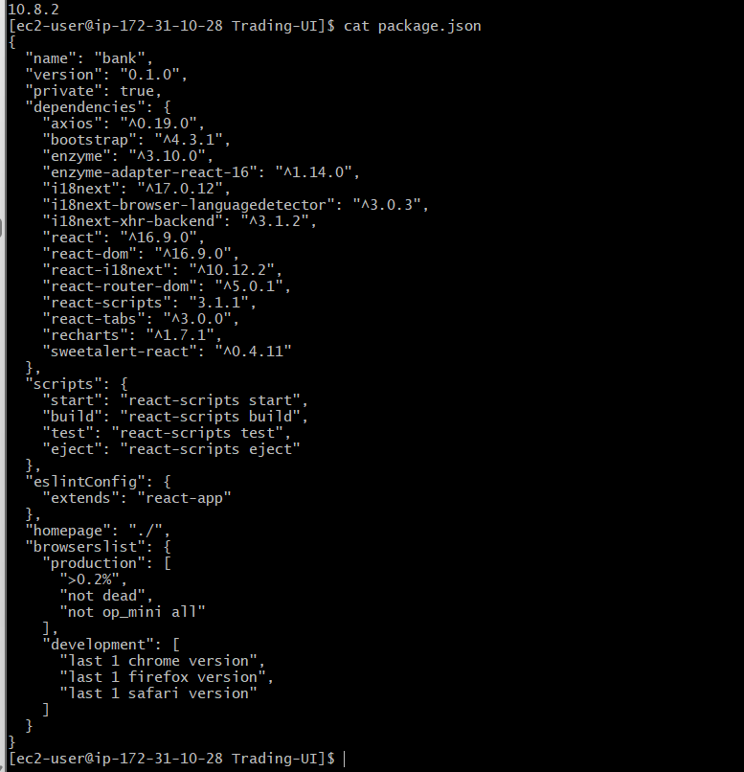

STEP 4 — Test Application Manually
Before Jenkins, test it manually.
npm install
Then:
npm test
Then:
npm run build
If all three work:
INSTALL ✅
TEST ✅
BUILD ✅
then move to Jenkins.
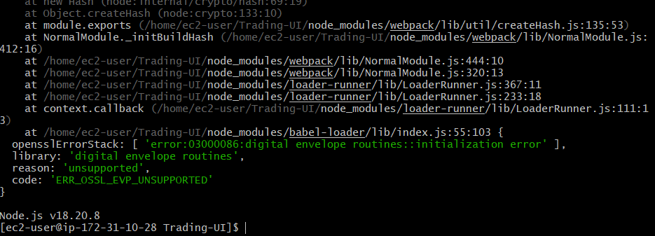

STEP 5 — Install Jenkins NodeJS Plugin
Go to:
Manage Jenkins
↓
Plugins
↓
Available plugins
Search:
NodeJS
Install:
NodeJS Plugin
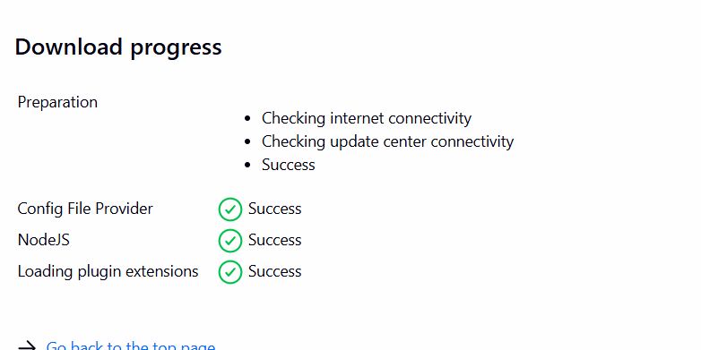

STEP 6 — Configure Node.js
Go to:
Manage Jenkins
↓
Tools
Find:
NodeJS installations
Click:
Add NodeJS
Example:
Name:

nodejs
Select an appropriate Node.js version.
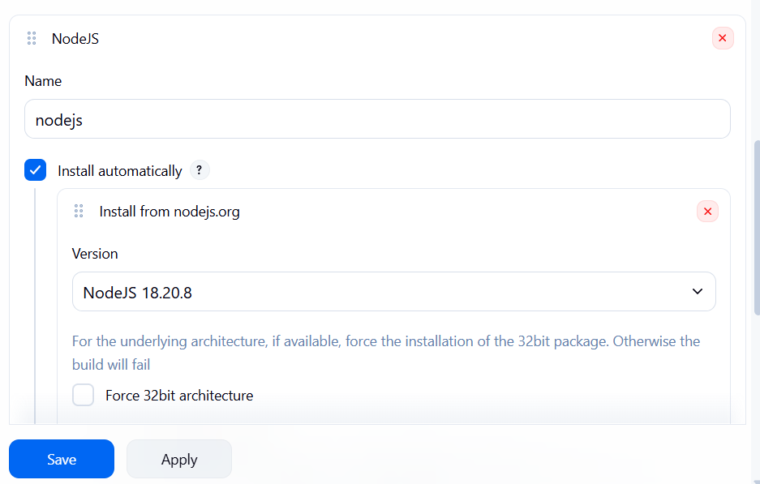

STEP 7 — Create Jenkins Job
Go to:
New Item
Name:
Trading-UI-CI-CD
Select:
Pipeline
Click:
OK
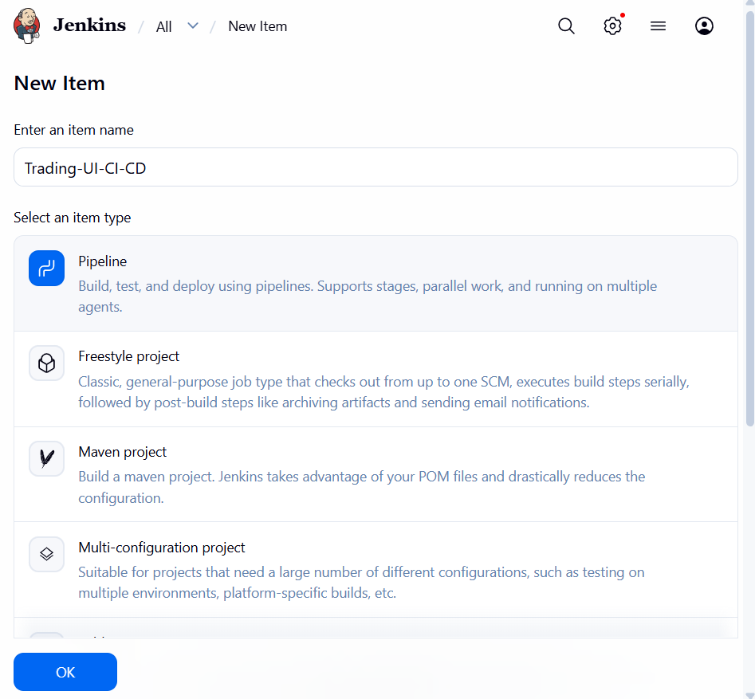

TEP 8 — Create Pipeline, in Jenkins Definition select:
✅ Pipeline script from SCM
Then configure:
Definition: Pipeline script from SCM
SCM: Git
Repository URL: https://github.com/venugh8899/terraform-jenkins-demo.git
Branch: */main
Script Path: Jenkinsfile
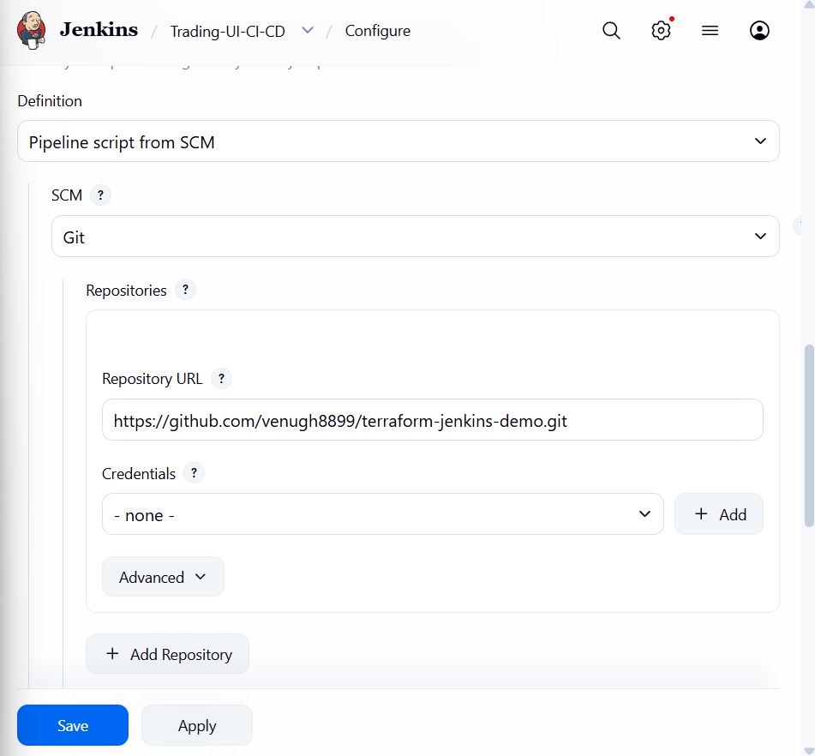

STEP 9 — Run Jenkins
Click:
Build Now
Pipeline:
Checkout
↓
Node Version
↓
Install Dependencies
↓
Test
↓
Build
↓
SUCCESS

STEP 10 — Check Jenkins Console
Click:
Build #1
↓
Console Output
You should see:
node --version
npm --version
npm install
npm test
npm run build
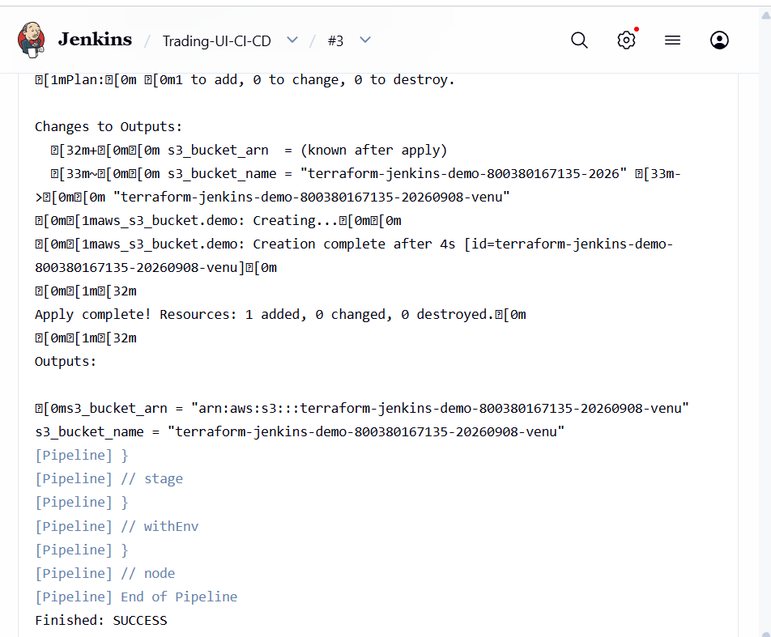

STEP 11 — Make It Real CI/CD
Now configure automatic triggering.
Go to:
Job
↓
Configure
↓
Build Triggers
For GitHub webhook-based CI:
GitHub hook trigger for GITScm polling
Then configure the webhook in GitHub.
Conceptually:
Developer pushes code
↓
GitHub
↓
Webhook
↓
Jenkins
↓
Checkout
↓
npm install
↓
npm test
↓
npm run build
↓
Deploy

STEP 12 — Add Deployment
CI means:
Build + Test
CD means:
Build + Test + Deploy
For a frontend application, one common architecture is:
Jenkins
|
v
npm run build
|
v
dist/
|
v
S3
|
v
CloudFront
|
v
Users
For example:
stage('Deploy') {
steps {
sh '''
aws s3 sync dist/ s3://YOUR-BUCKET/
aws cloudfront create-invalidation \
--distribution-id YOUR_DISTRIBUTION_ID \
--paths "/*"
'''
}
}
Don't put AWS access keys directly in the Jenkinsfile. Use Jenkins credentials or an IAM role.

TASK 5 — Explain 10 Maven Commands
First understand:
Maven
|
+-- Build
+-- Test
+-- Package
+-- Dependency management
+-- Deployment
Maven uses lifecycle phases such as:
validate
compile
test
package
verify
install
deploy
The official Maven documentation describes the standard syntax as:
mvn [options] [goals/phases]
and documents the default lifecycle phases.

1. mvn --version
mvn --version
or:
mvn -v
Purpose
Checks Maven version.
Example:
Apache Maven 3.x.x
Java version: 17
Interview
Used to verify Maven installation and Java environment.

2. mvn validate
mvn validate
Purpose
Checks whether the Maven project is correctly configured.
It validates things such as:
pom.xml
project structure
configuration

3. mvn compile
mvn compile
Purpose
Compiles the source code.
Flow:
src/main/java
|
v
compile
|
v
target/classes

4. mvn test
mvn test
Purpose
Runs unit tests.
Flow:
Source Code
↓
Compile
↓
Unit Tests
↓
PASS / FAIL

5. mvn package
mvn package
Purpose
Builds the application package.
For example:
JAR
WAR
Example:
target/
|
└── application.jar

6. mvn verify
mvn verify
Purpose
Performs checks to verify that the package meets quality criteria.
This happens after:
compile
test
package
and is useful for CI pipelines.

7. mvn install
mvn install
Purpose
Builds the project and installs the artifact into the local Maven repository.
Local repository:
~/.m2/repository
Flow:
Source
↓
Compile
↓
Test
↓
Package
↓
Install
↓
~/.m2/repository

8. mvn clean
mvn clean
Purpose
Deletes the previous build output.
Usually:
target/
is removed.
Why?
Suppose yesterday:
target/
contains an old build.
Running:
mvn clean
removes it.
Then:
mvn package
creates a fresh build.

9. mvn dependency:tree
mvn dependency:tree
Purpose
Shows project dependencies and their relationships.
Example:
my-application
|
+-- spring-core
|
+-- spring-web
|
+-- jackson
|
+-- logging
Very useful when troubleshooting:
dependency conflicts
version conflicts
transitive dependencies

10. mvn clean install
mvn clean install
This is one of the most commonly used commands in Jenkins.
It means:
clean
↓
compile
↓
test
↓
package
↓
install
Example Jenkins stage:
stage('Maven Build') {
steps {
sh 'mvn clean install'
}
}

⭐ 10 Maven Commands — Quick Revision
# | Command | Purpose
1 | mvn --version | Check Maven version
2 | mvn validate | Validate project
3 | mvn compile | Compile source code
4 | mvn test | Run tests
5 | mvn package | Create JAR/WAR
6 | mvn verify | Verify build
7 | mvn install | Install artifact locally
8 | mvn clean | Delete previous build
9 | mvn dependency:tree | Display dependencies
10 | mvn clean install | Clean + build + test + package + install
Maven's current documentation also supports options such as -D for defining properties, -P for activating profiles, -B for batch mode, and -U for updating dependencies.

